**Virtual Reality (VR) Shopping Platform: Shop360**



A Project submitted to the Department of Computer Science and Engineering,

Hajee Mohammad Danesh Science and Technology University

Course Title: Software Engineering

Course Code: CSE 305

|  |  |
| --- | --- |
| **Submitted To,**  Pankaj Bhowmik  Lecturer  Department of Computer Science and Engineering | **Submitted By,**  Abdur Razzak  Student ID: 2102042  Level 3, Semester I |

DEPARTMENT OF COMPUTER SCIENCE AND ENGINEERING

HAJEE MOHAMMAD DANESH SCIENCE AND TECHNOLOGY UNIVERSITY, DINAJPUR-5200, BANGLADESH

**Virtual Reality (VR) Shopping Platform: Shop360**

The objective of this project is to create a cutting-edge Virtual Reality (VR) Shopping Platform named *"Shop360"*. The platform will allow users to explore virtual stores, try on products, and complete purchases in an immersive VR environment. The **Agile Software Development Model** will be employed to ensure flexibility, rapid development, and continuous user feedback.

How this will work :

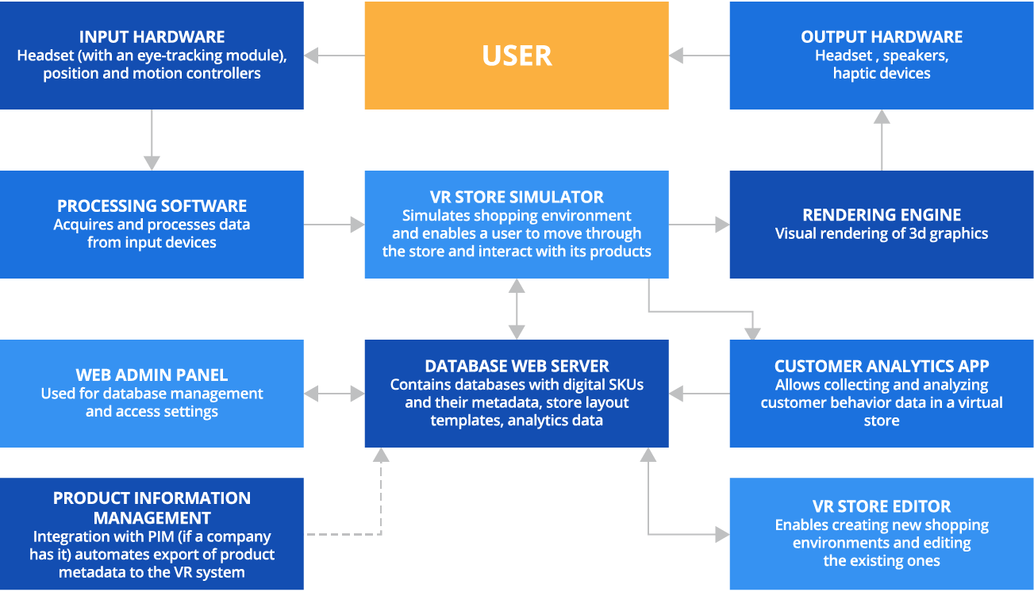

**Applying the Agile Model**

**1. Agile Framework Selection:**

* Use **Scrum** as the Agile framework to organize development into sprints (2-3 weeks each).
* Roles:
  + **Product Owner:** Defines and prioritizes features (e.g., store navigation, virtual try-on).
  + **Scrum Master:** Facilitates Agile practices and removes development roadblocks.
  + **Development Team:** Builds, tests, and delivers the product incrementally.

**Agile Development Process for Shop360**

**Phase 1: Project Initiation and Backlog Creation**

* Define a **Product Backlog** of features:
  + Immersive 3D environment for virtual shopping.
  + VR controls for navigation and item selection.
  + Product try-on feature (e.g., for clothes and accessories).
  + Secure payment gateway and user profile management.
  + Real-time collaboration for multi-user shopping.
* Prioritize tasks using **MoSCoW** method:
  + **Must-Have:** Core VR shopping features, secure payments.
  + **Should-Have:** Realistic product animations and details.
  + **Could-Have:** Voice assistance, AR integration.
  + **Won’t-Have (for now):** Multi-currency support, offline mode.

**Phase 2: Sprint Planning and Development**

Break down the development into **sprints**, with each focusing on specific features.

**Sprint 1: Basic Virtual Store Setup**

* Develop a basic VR environment with sample product displays.
* Implement navigation mechanics (teleportation or movement).
* Include a simple user interface (UI) for browsing products.

**Sprint 2: Virtual Try-On Feature**

* Add functionality for users to try on products virtually (e.g., overlay clothes on a 3D avatar).
* Ensure accurate sizing and realistic textures for products.

**Sprint 3: Cart and Checkout System**

* Implement the ability to add items to a virtual cart.
* Create a secure payment gateway integration.
* Design user profiles to save preferences and purchase history.

**Sprint 4: Advanced Interactions and Multi-User Features**

* Add multi-user shopping experiences (e.g., friends shopping together in VR).
* Integrate advanced features like voice commands for hands-free shopping.

**Phase 3: Regular Testing and Feedback**

* Conduct **Daily Standups** to discuss progress, challenges, and next steps.
* Perform **Sprint Reviews** at the end of each sprint:
  + Present the product increment to stakeholders and gather feedback.
  + Use the feedback to refine the **Product Backlog** and plan the next sprint.
* Use **Continuous Testing**:
  + Functional testing: Ensure features work as intended.
  + Usability testing: Verify ease of use in VR.
  + Performance testing: Test for lag-free VR experience.

**Phase 4: Deployment and Maintenance**

* After completing all planned sprints, deploy the product to users.
* Gather real-world feedback to create a **Release Backlog** for future updates.
* Maintain and update the platform based on user suggestions and new trends.

**Key Agile Practices for Shop360**

1. **Iterative Development:** Deliver a working version of the product at the end of every sprint.
2. **Customer Collaboration:** Regularly involve stakeholders and potential users to validate features.
3. **Flexibility:** Adapt to changing requirements based on user feedback.
4. **Time-Boxing:** Complete each sprint within a fixed timeline.

**Advantages of Using Agile for Shop360**

* **User-Centric Design:** Constant feedback ensures the product meets user needs.
* **Faster Delivery:** Incremental releases allow the delivery of functional features sooner.
* **Reduced Risks:** Continuous testing and feedback prevent major issues during deployment.
* **Flexibility:** Easily accommodates changes in requirements or priorities.

By using the **Agile Model**, *Shop360* will evolve through continuous iterations, ensuring it becomes a highly immersive and user-friendly VR shopping platform.